**Technical Document: Version-1.0.0**

**Project**: **LMS**

**Required Software:**

1. SpringToolSuite4
2. apache-maven-3.6.3-bin
3. Spring boot -2.0.1
4. openjdk-8-jre
5. Jenkins
6. Docker
7. Kubernetes
8. Git/ tortoise git as client
9. Aws console
10. Mongodb
11. Slf4j Logging Lombok
12. Reactjs for UI
13. RabbitMQ/ activeMQ for messaging
14. Redis cache

**Microservices architecture:**

1. Circuit breaker design pattern
2. SAGA/ choreography DP
3. Zuul Api Gateway
4. Eureka Registry
5. Config Server
6. DB services
7. Communication using REST Template / Feign Client

**List of Microservice:**

1. Booking service
2. Acounting Services
3. Notifiation Services

**Architecture of Microservices:**

**Monolithic architecture Vs Micro services:**

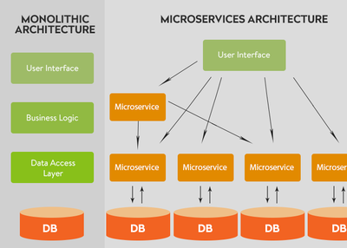

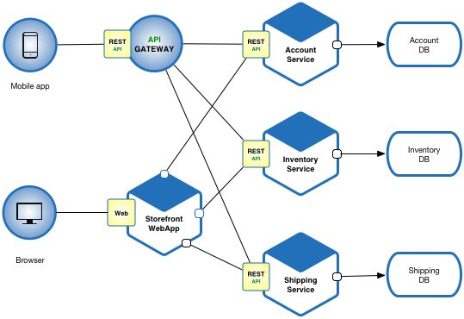

**Communication:**

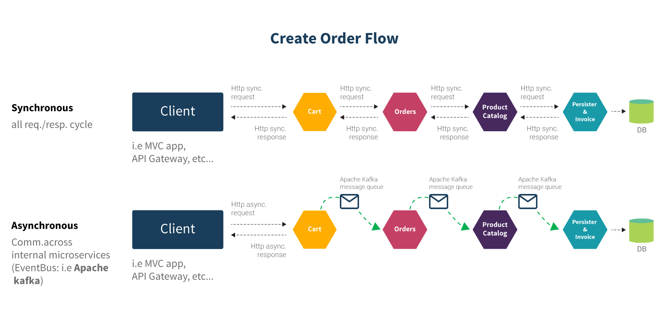

**Api gateway zuul and Service Registry:**

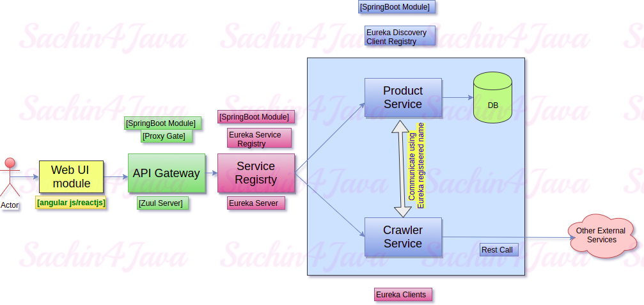

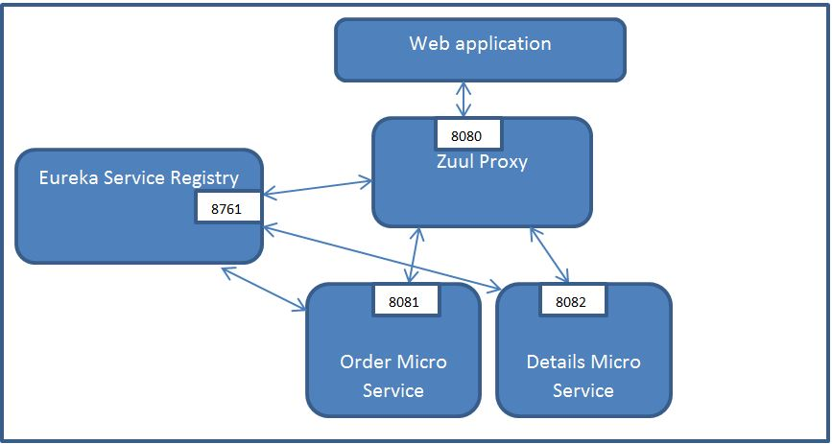

**Oauth2 for security:**

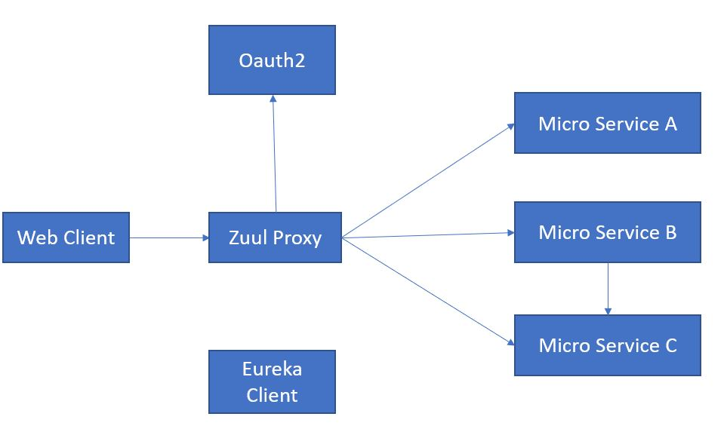

**Micro services Design:**

1. **Order Booking Service**
2. **POJO**
3. **Class AirwaybillDto {**
4. **private** Date createdDate;
5. **private** Date weightDimensionVerifiedDate;
6. **private** Date weightDimensionforcedDate;
7. **private** String weightDimensionVerifiedAgent;
8. **private** String weightDimensionForceAcceptedAgent;
9. **private** String weightDimensionVerificationStatus;
10. **private** String goodsLocation;

**}**

1. **Class BookingDto.java {**
2. **private** String bookingControlStation;
3. **private** String bookingControlStatus;
4. **private** String bookingCreationSource;
5. **private** String bookingCreationDestination;
6. **private** String rebookReasonCode;
7. **private** Date bookingDateTime;
8. **private** String bookingReferenceNumber;
9. **private** FlightInfoDto arrivalFlight1;
10. **private** String userPhone;
11. **private** String userEmail;

**}**

1. **class** FlightInfoDto **implements** Serializable{
2. **private** Date flightDate;
3. **private** String flightNumber;

**}**

1. **Controller Name**
2. **Service**
3. **DAO**
4. **DB**

**Endpoints:**

1. **POST**
2. **GET**
3. **PUT**
4. **DELETE**
5. **PATCH**
6. **Accounting Service**
7. **POJO**
8. **Controller Name**
9. **Service**
10. **DAO**
11. **DB**

**Endpoints:**

1. **POST**
2. **GET**
3. **PUT**
4. **DELETE**
5. **PATCH**
6. **Notification Service**
7. **POJO**
8. **Controller Name**
9. **Service**
10. **DAO**
11. **DB**

**Endpoints:**

1. **POST**
2. **GET**
3. **PUT**
4. **DELETE**
5. **PATCH**